

**Semester I 2024/2025**

(SECP1513-08)

TECHNOLOGY AND INFORMATION SYSTEMS

**DESIGN THINKING PROJECT:**

**MedLink System Integrated App**

**(Group 2)**

**Lecturer:**

Dr. Suriati binti Sadimon

**Group Member:**

Nicole Lee A24CS0287

Sam Wei Leng A24CS0295

Aw Xu Yuen A24CS0052

Lai Shi Ni A24CS0298

Crystal Yap Wen Jing A24CS0240

**Table of contents**

**Introduction 3**

**Timeline 4**

**Empathy 5**

3.1 The Users’ Needs 5

3.2 Evidence 6

**Define 7**

4.1 Framing The Problem 7

4.2 Evidence 8

**Ideate 9**

5.1 Solution 9

5.2 Evidence 10

**Prototyping 11**

6.1 Prototype 11

6.2 Evidence 30

**Test 31**

7.1 Testing 31

7.2 Evidence 31

**Assessment Point 32**

**Reflection 33**

**Task Distribution List 35**

**References 36**

# Introduction

Design thinking is a problem-solving’s process through collaborative designs on innovation. This project aimed to address the real-world challenge itself and improve our critical teamwork, problem-solving and communication.

Effective healthcare services are critical in ensuring public health and well-being. However, the manual processes used in healthcare systems mostly lead to inefficiencies, affecting patient outcomes. Therefore, the development of an integrated system is necessary to solve the problems for both patients and healthcare providers. In this report, we introduced the MedLink System Integrated App — a comprehensive solution addressing the challenges through the design thinking process.

The MedLink System enhances the efficiency and accessibility of healthcare. It is designed to help daily operations within hospitals, ensuring that patients feel attended to. It strengthens the bond between health providers and the patients through tools and features provided.

# 

# Timeline

|  |  |
| --- | --- |
| **November** | |
| **Timeline** | **Task** |
| 6 -7 | Discussion and finalization of the project's title— MedLink System Integrated App. |
| 8 -9 | Empathy phase: Conduct interviews to gather insights and users’ needs. Composite characters’ research and development. |
| 13 | Title presentation and approval from the lecturer. |
| **December** | |
| 11-18 | Define phase: Analyze findings to articulate the problem.  Ideate phase: Brainstorm and develop potential solutions. |
| 20 -30 | Prototype was created with specific features to represent the proposed solution. |
| **January** | |
| 1- 2 | Test phase : Test running prototype from user. |

# 

# 

# Empathy

## 3.1 The Users’ Needs

To explore the users' needs, we conducted interviews and created composite characters as typical users within the healthcare system.

Our interviewees, Yap Wen Kang and Crystal Yap, shared their patients’ experiences within the government healthcare system. They also shared challenges like lack of convenience, inefficiencies in time management, and limited access to personal medical data. For our composite characters, their background and challenges are shown in the table below.

Table below shows the background and challenges faced by composite characters :

|  |  |
| --- | --- |
| **User** | **Challenges** |
| **Name:** Joanne, 28  **Background:**  Nurse in a government hospital outpatient ward. | She frequently handles manual data entry for patient registration and encounters problems of delay or errors in patient information. She finds it difficult to keep the process organized when the government hospital is often overcrowded in the waiting area. She also noticed a lack of real-time communication tools between doctors and other departments results in delays in patient care. |
| **Name:** Dr. Syed, 45  **Background:**  General practitioner in a busy government clinic. | He struggled with fragmented patient medical records, patient histories scattered in different departments, hard to access during consultation. He is also overwhelmed by high patient volume, difficult to prioritize patient according to conditions or urgent cases |

By combining insights from interviews and developing composite characters, we gathered the difficulties from patients and medical staff in government healthcare institutions.

## 3.2 Evidence

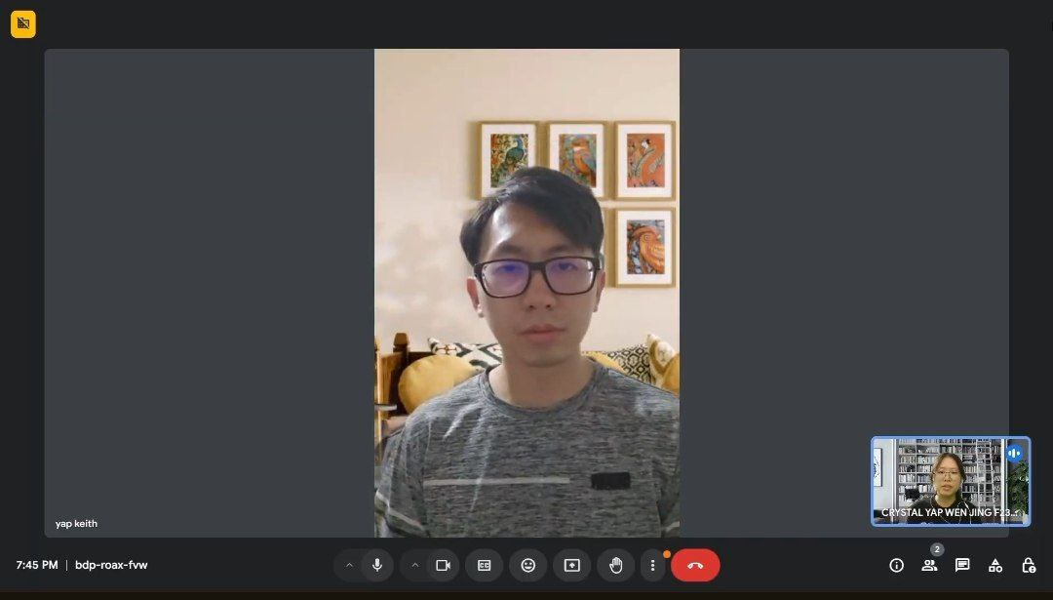



# Define

## 4.1 Framing The Problem

Manual data processing in hospitals like patients repeatedly filling out personal information and manual data entry by healthcare staff may lead to administrative burden and limited number of manageable patients.

Next, long waiting times in government hospitals cause delays in treatment or appointments of serious illness patients. This may cause societal impact like increase of healthcare avoidance, and loss of trust.

Lack of continuous patient monitoring is also a problem for patients with chronic disease and post-surgery recovery. Patients may not notice health deterioration until serious complications arise and delayed interventions.

Inadequate communication between patients and doctors is another critical issue. Insufficient post-consultation records may lead to inaccuracies in diagnoses and medications. Besides, limited healthcare access in remote locations or villages leaves many without timely care during emergencies, increasing risks in critical situations.

Lastly, incomplete and inaccessible patient medical records lead to fragmented care and delayed treatments during emergencies or for the management of chronic illnesses.

## 4.2 Evidence

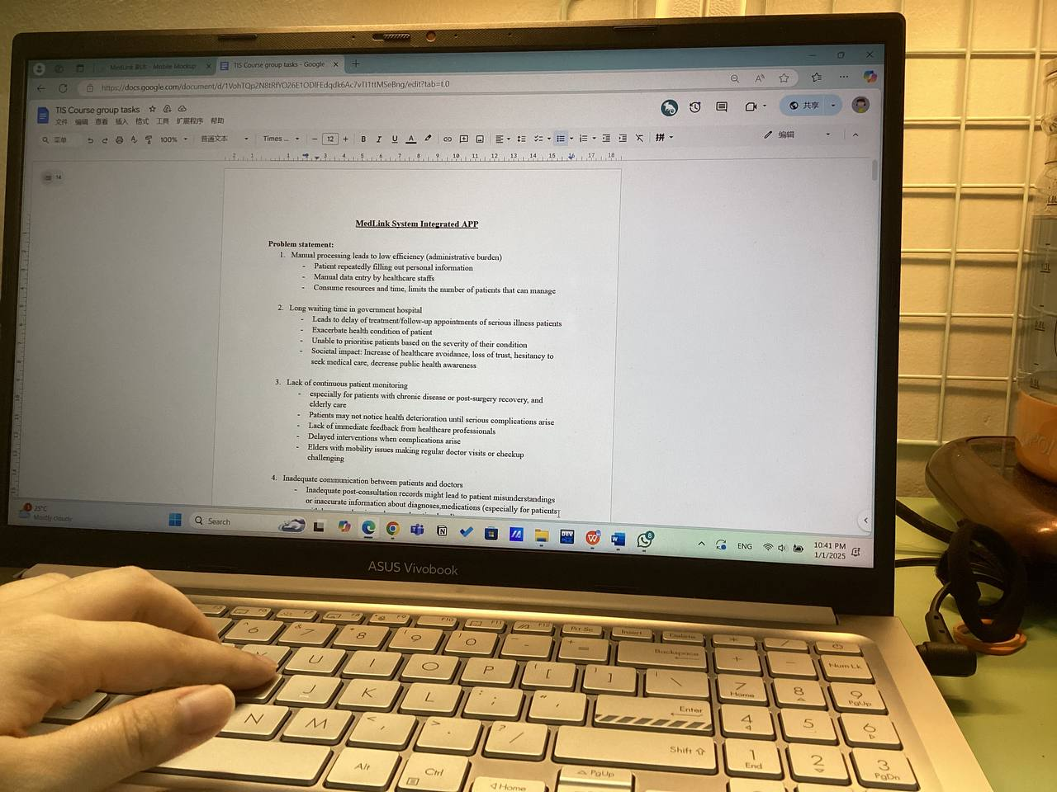

# Ideate

## 5.1 Solution

A digital patient registration system in MedLink System enabling automated data entry through smart forms. Patients can update their medical history.

It has a smart appointment scheduling system that prioritizes patients based on their symptoms. Reminders for appointments provided to improve compliance. Moreover, a real-time queue tracking function enables patients’ flexibility.

Post-hospital care features include health trackers that synchronize with wearable devices to record vital data such as blood pressure and telemedicine consultations for remote doctor interactions. Additionally, a central digital medical record system ensures seamless data sharing across providers, real-time updates, and emergency access to critical information. Patients benefit from post-consultation summaries, and detailed outpatient records.

The system also includes an emergency button for instant notifications to the nearest hospital, complete with location details and secure sharing of medical history for timely care.

Educational resources and health tips are personalized based on patients’ profiles, offering professional advice on preventive care and lifestyle.

## 5.2 Evidence

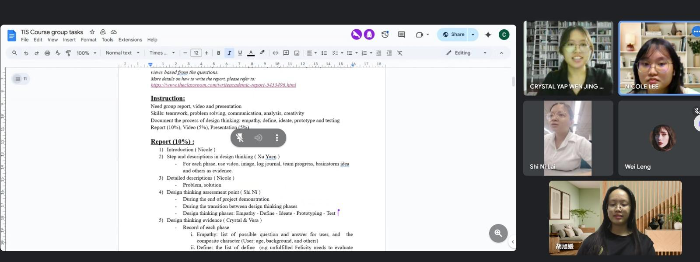

# Prototyping

## 6.1 Prototype

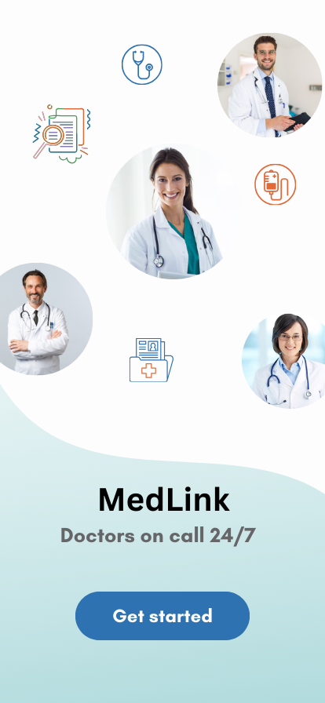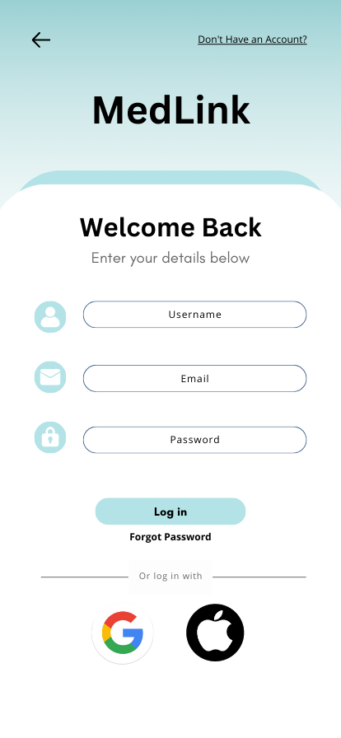

Log in by username, email and password. Click “Don’t have an account” to sign up users.

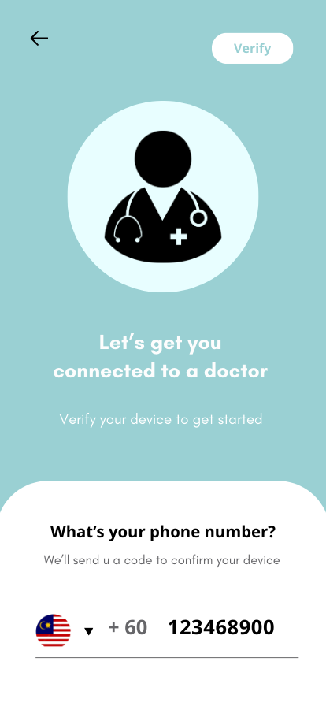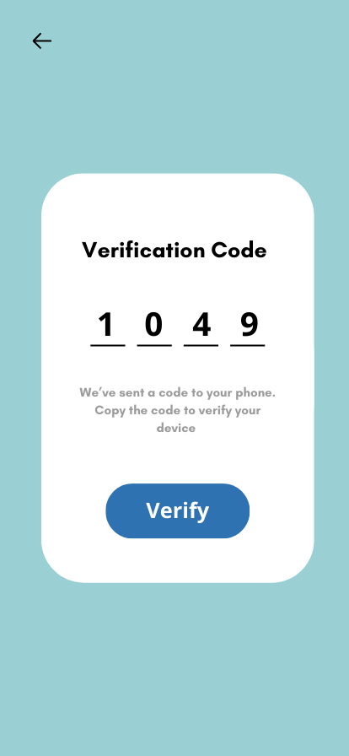

Phone number verification.

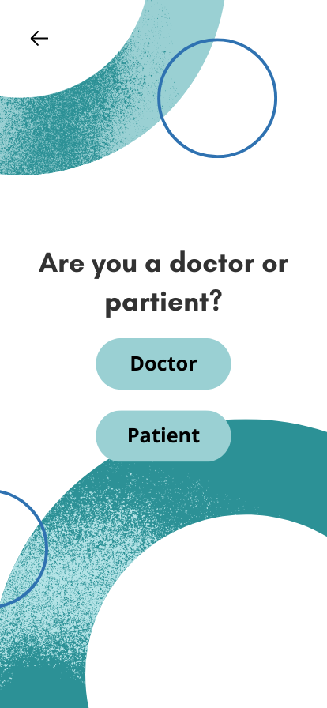

Choose your role as doctor or patient.

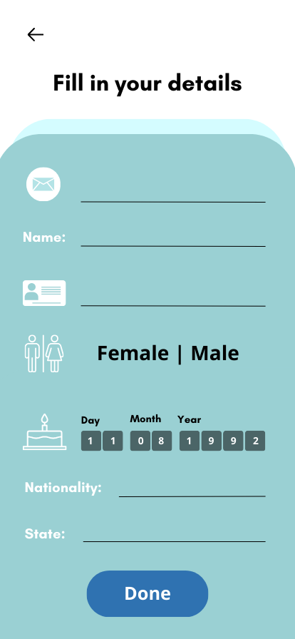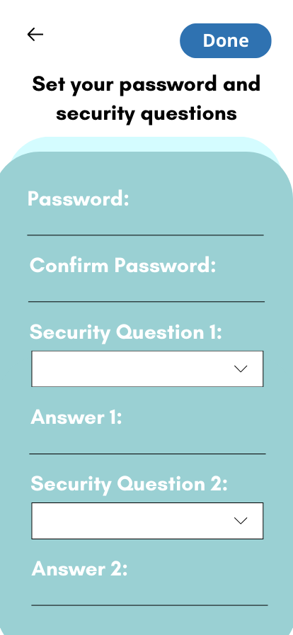

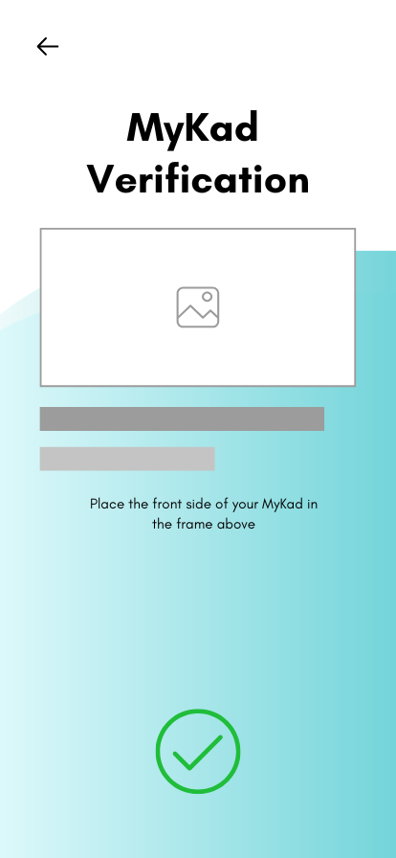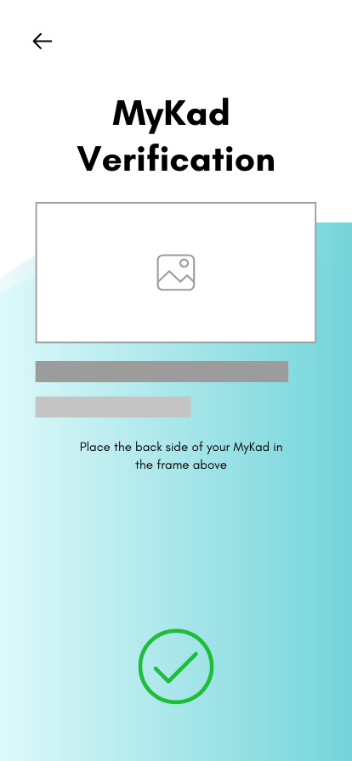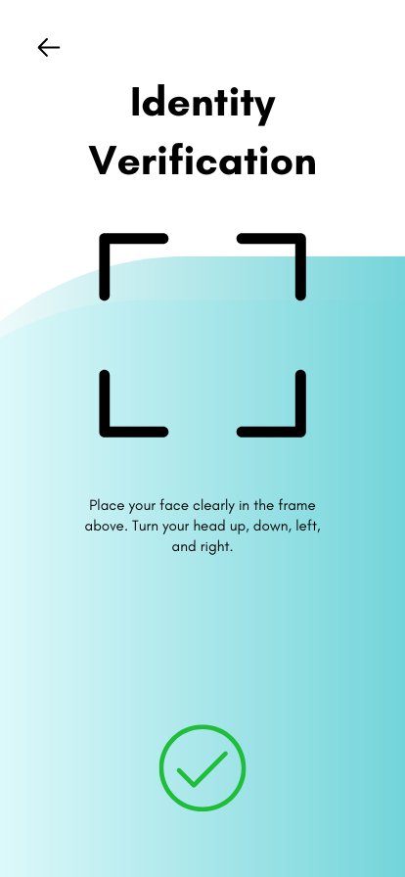

IC Verification

**For doctor,**

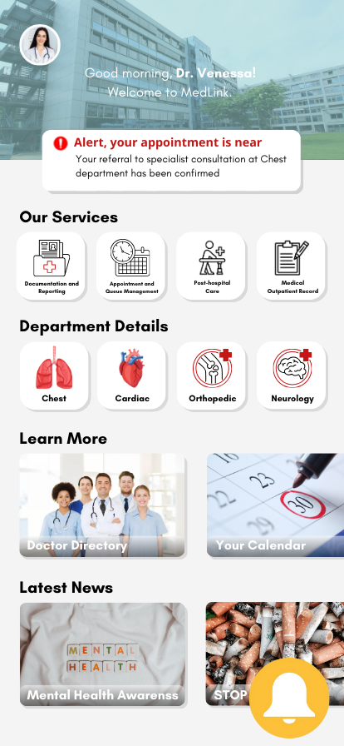

Home page and notification button

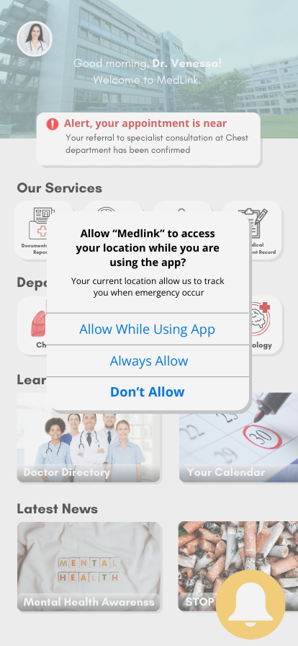 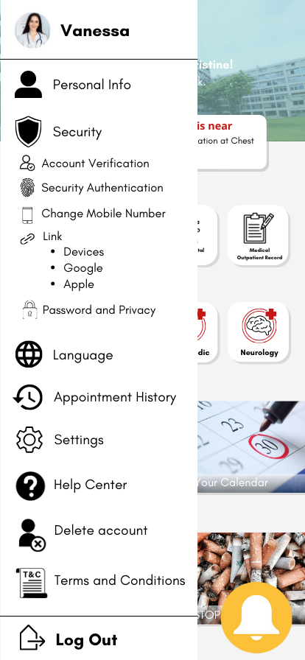

Permission for location tracking. Click the profile picture for your profile details.

**Documentation and Reporting Section**

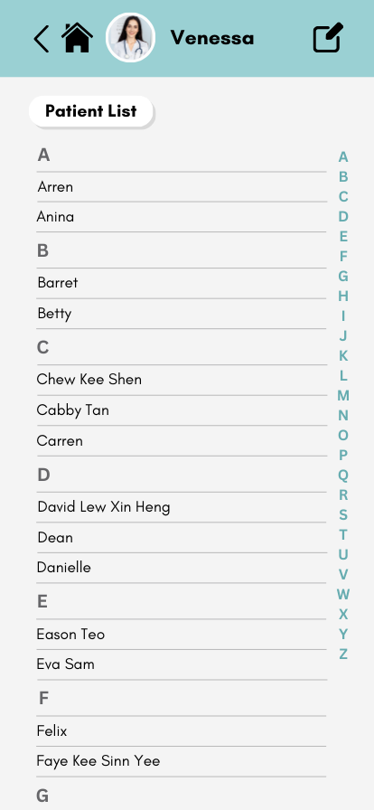 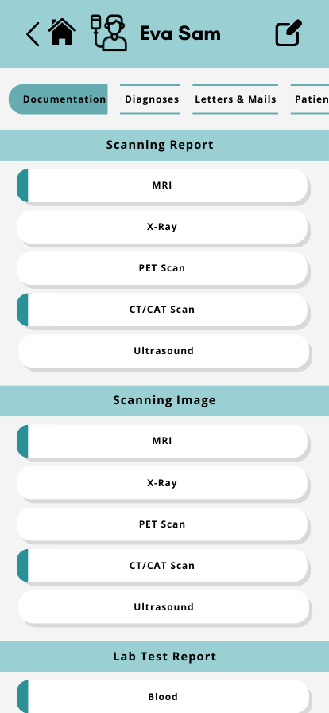

Patient list is shown. Click in for their information. Upload documents here.

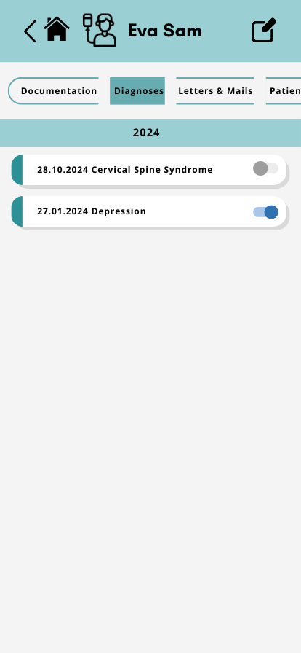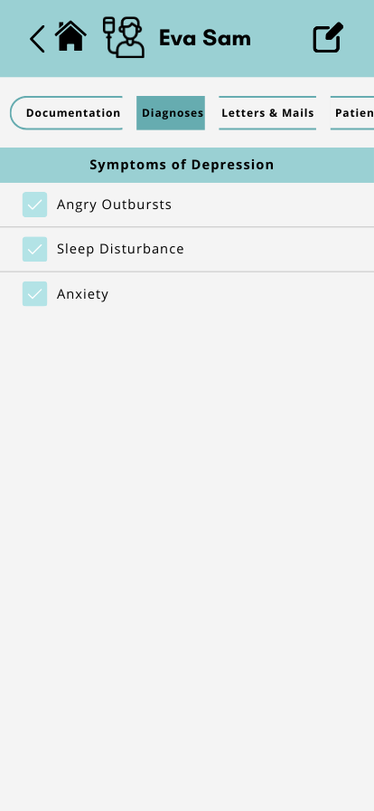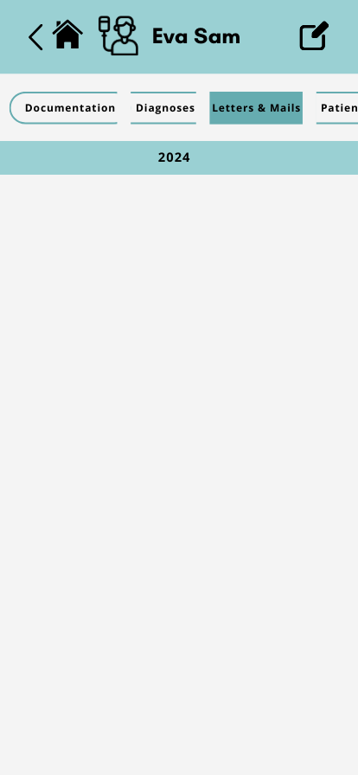

The patient’s diagnoses are shown here. Blue button indicated there is symptoms recorded. (Pic 2)

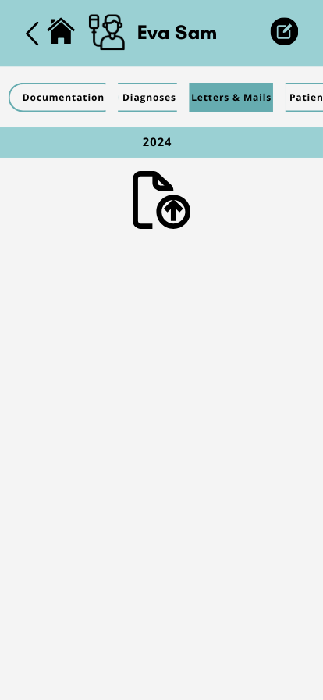 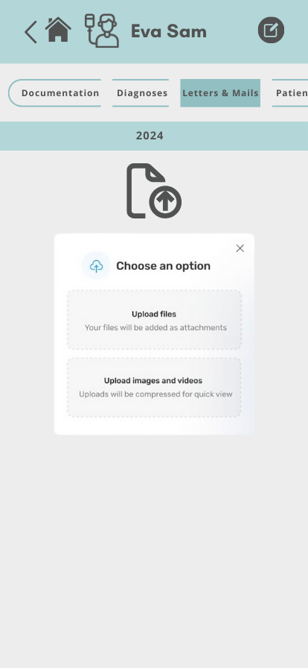 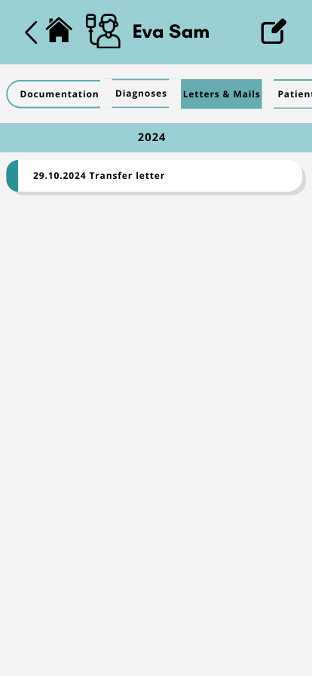  
 Edit button at the right top. Choose media to upload. Uploaded media is shown.

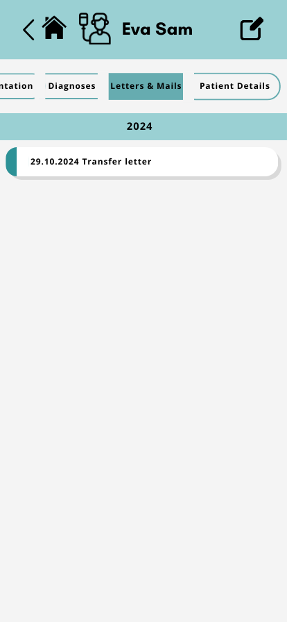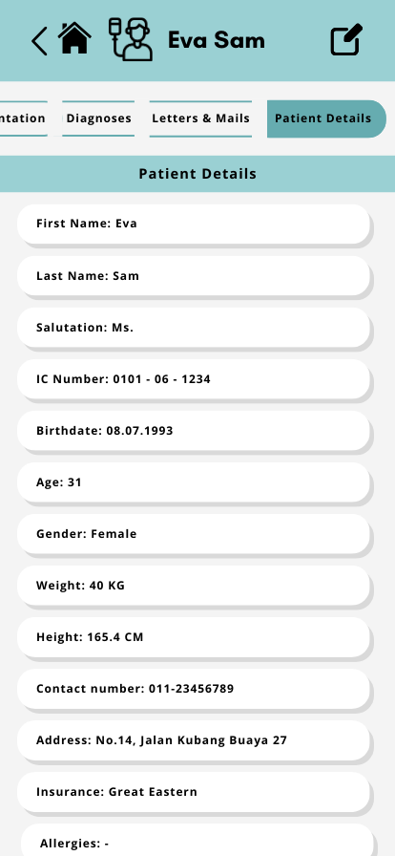

Patient details are displayed.

**Appointment and Queue Management**

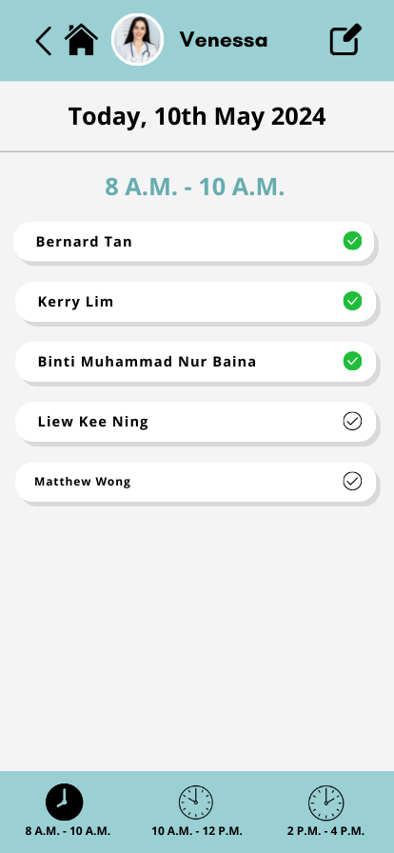

Show the daily slots of your appointment.

**Post-hospital Care**

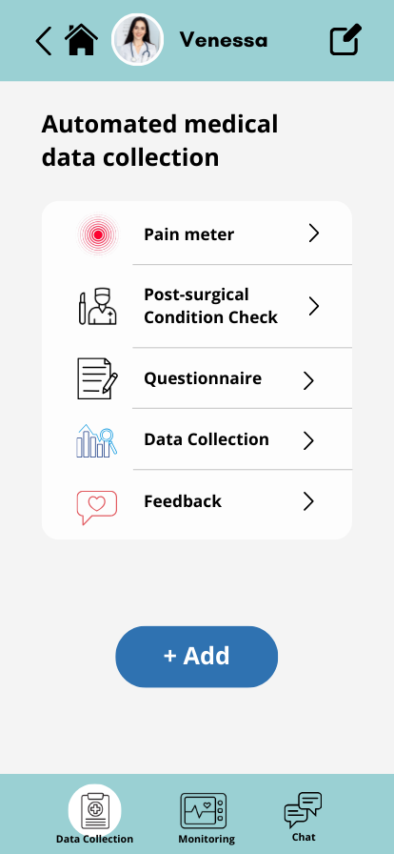

Health record from patient is under the data collection

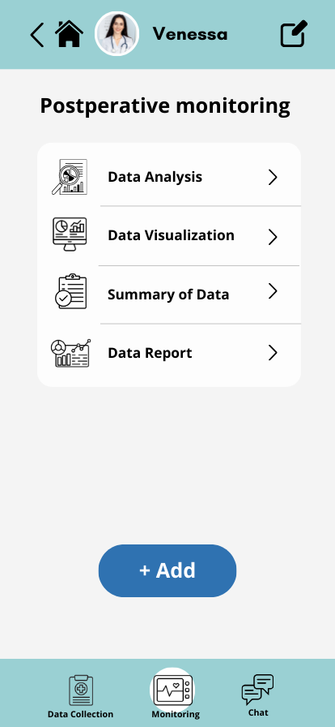 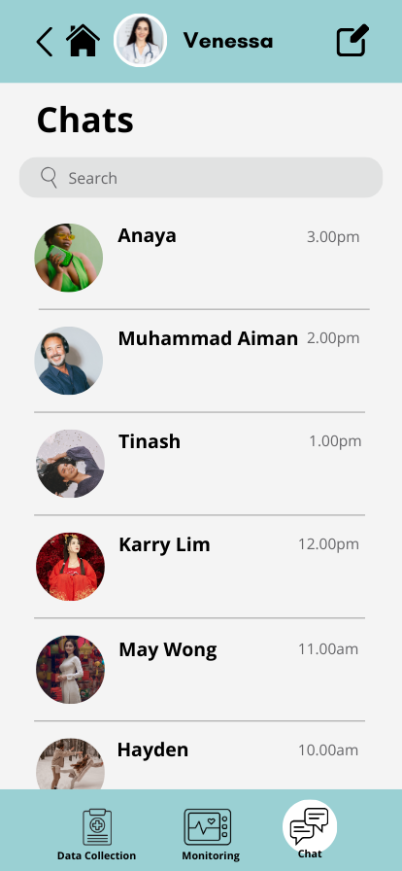

Analysed data by medical staff are shown. Live chat with patients.

**Medical Outpatient Record Your Calendar**

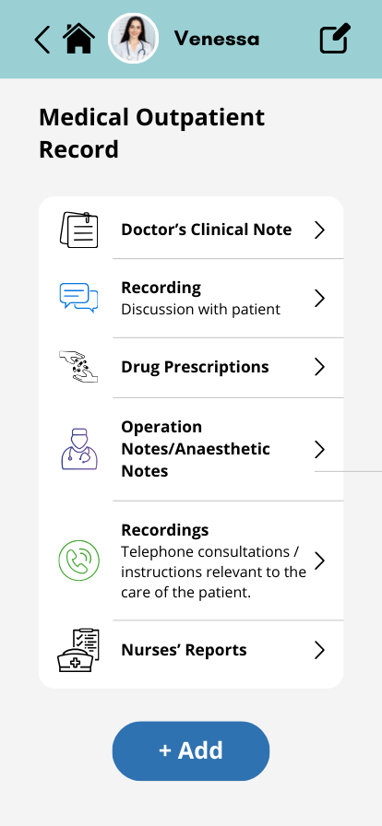 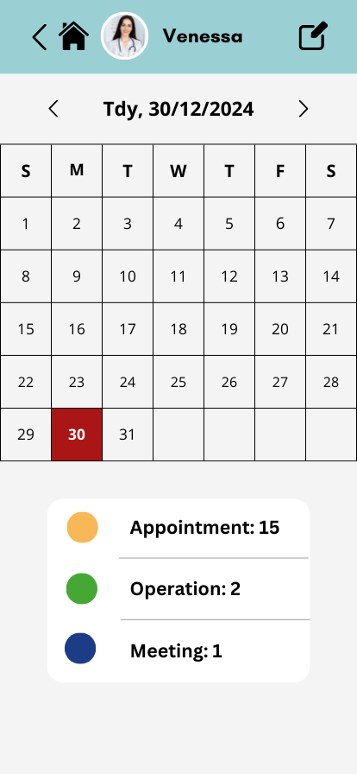

Every record can be seen by a patient. Schedule of the day is shown.

**For patient,**

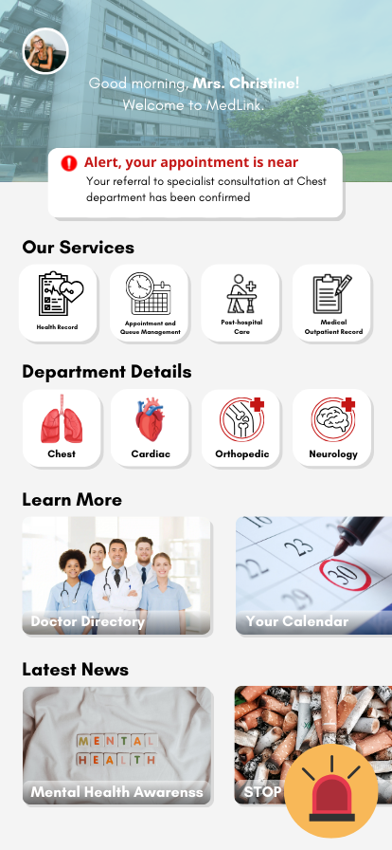

Home page with an emergent button.

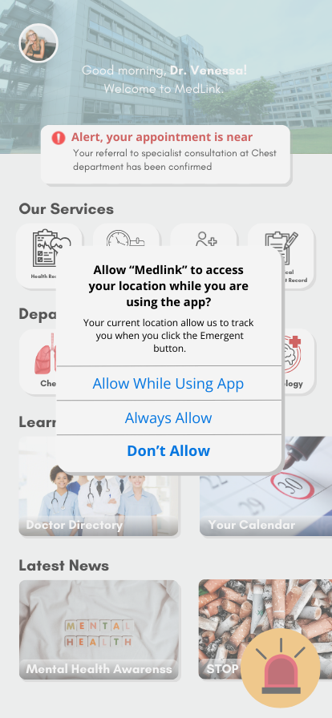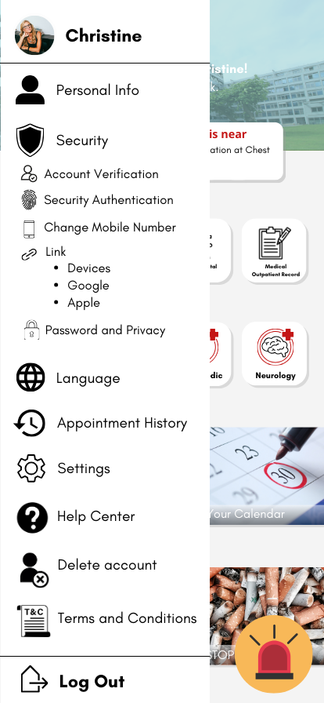

(Refer above)

**Health Record**

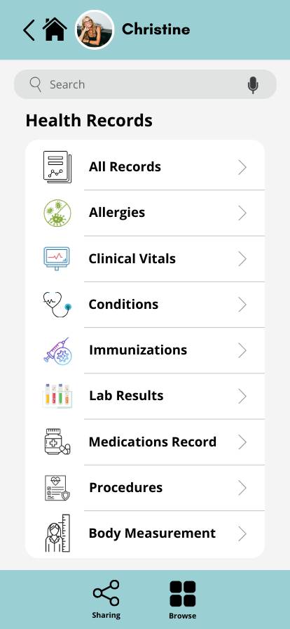

Physical indicators self-recording and the medical report.

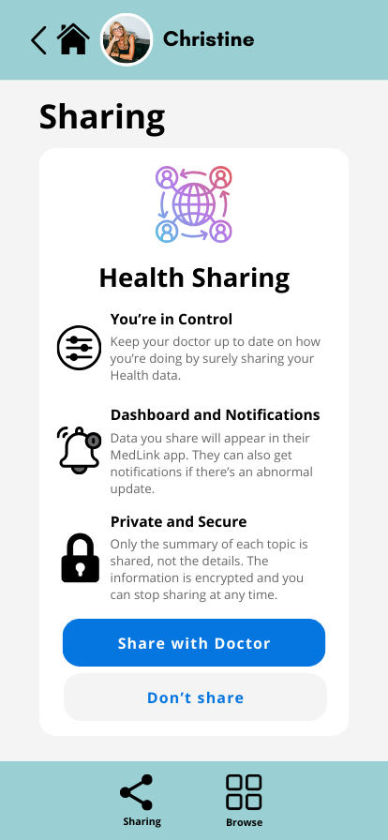

Sharing permission for your doctor to track your records.

**Appointment and Queue Management**

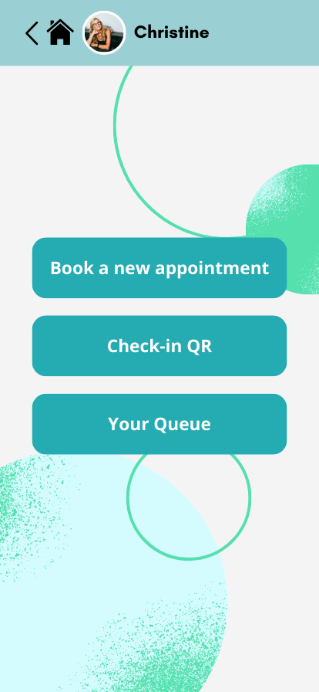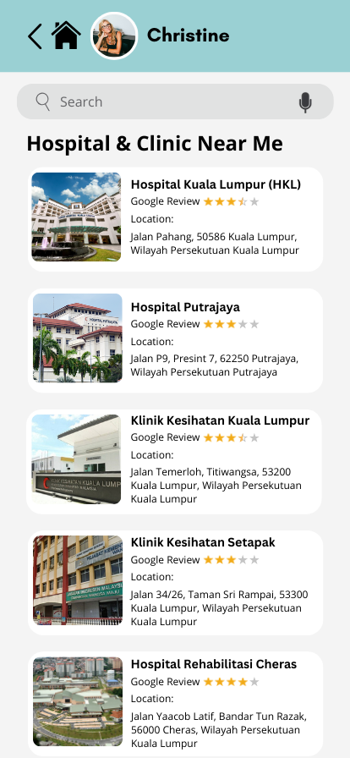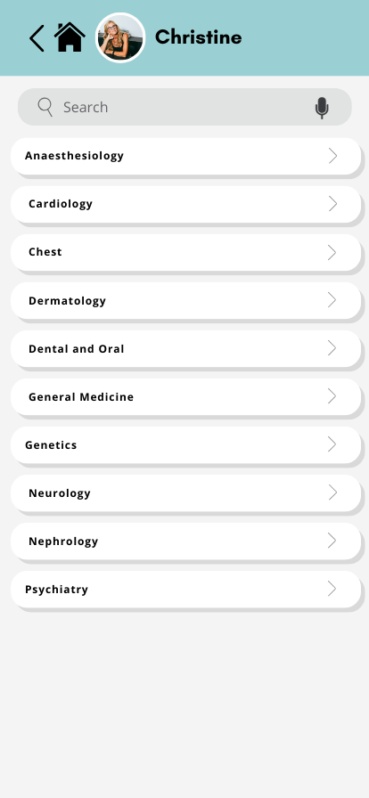   
 Choose an action. Choose a hospital/clinic. Choose a department for   
 appointment booking.

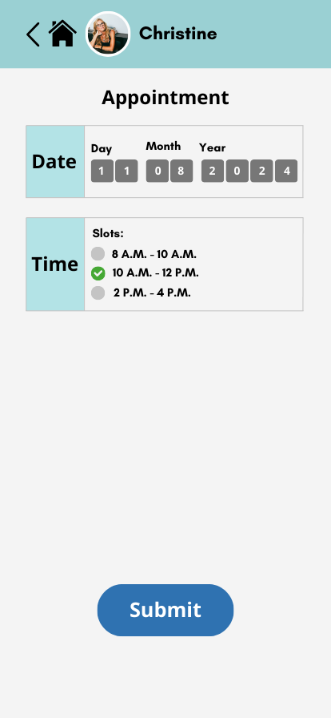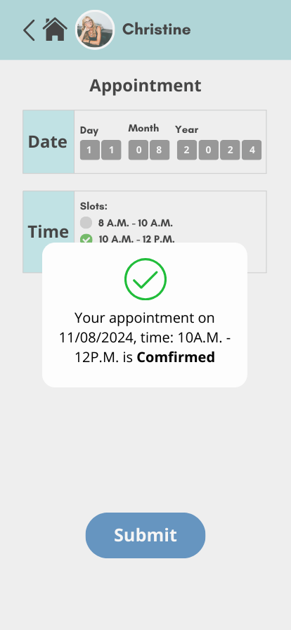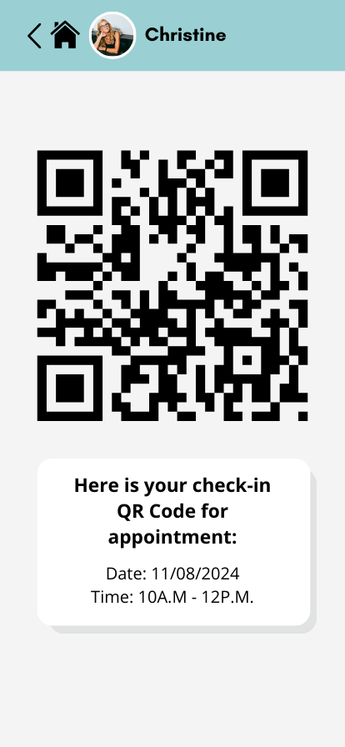   
 Choose date and time. A QR code is given for check-in on   
 the appointment’s day.

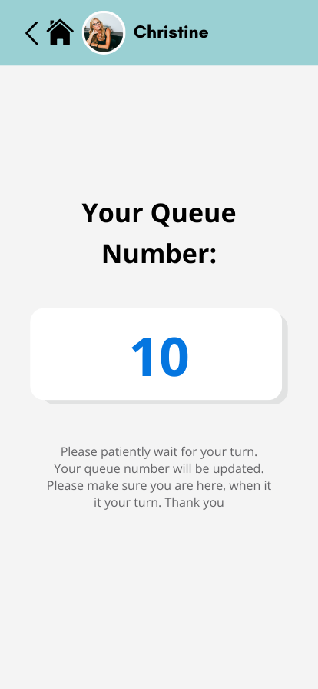

Get your queue number after checked in. The number will be real-time updated. Choose “Your Queue”, you can recheck your queue number.

**Post-hospital Care**

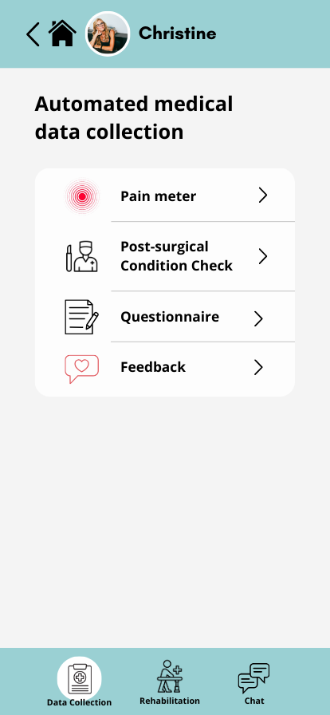   
 Fill in the info here.

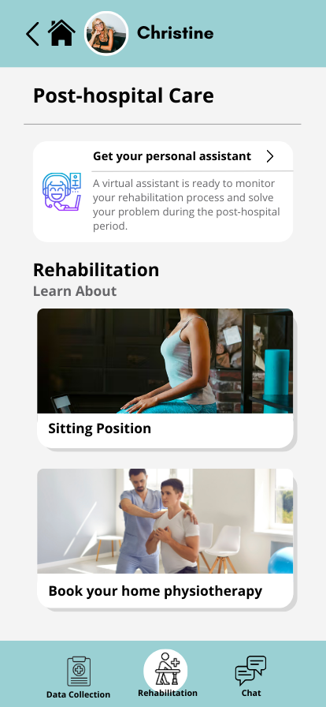

Rehabilitation’s knowledge and AI assistant are here.

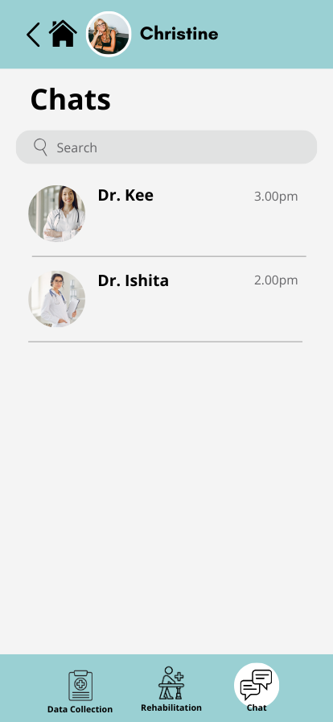

Live chat with doctor

**Medical Outpatient Record** **Your Calendar**

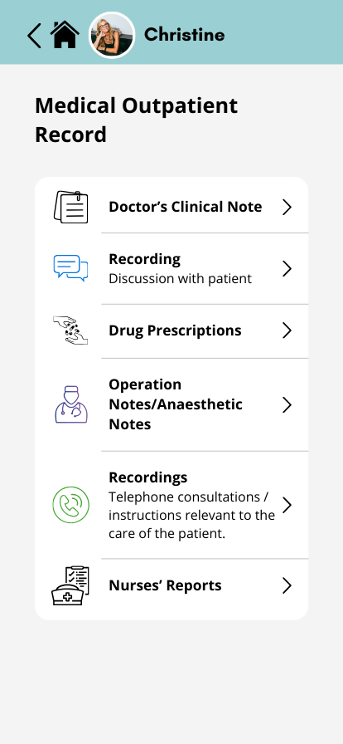 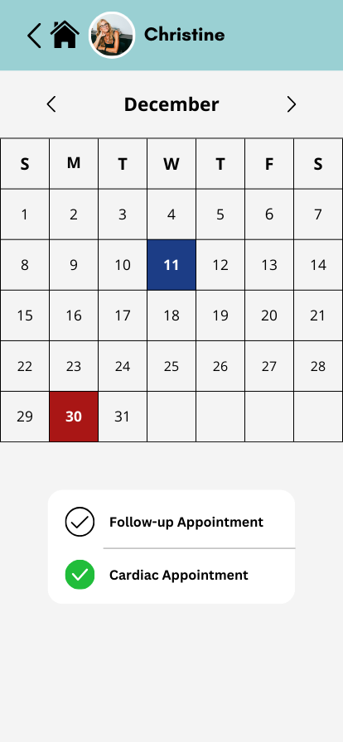

All the doctor uploaded records are shown here Your appointment of the month

## 6.2 Evidence

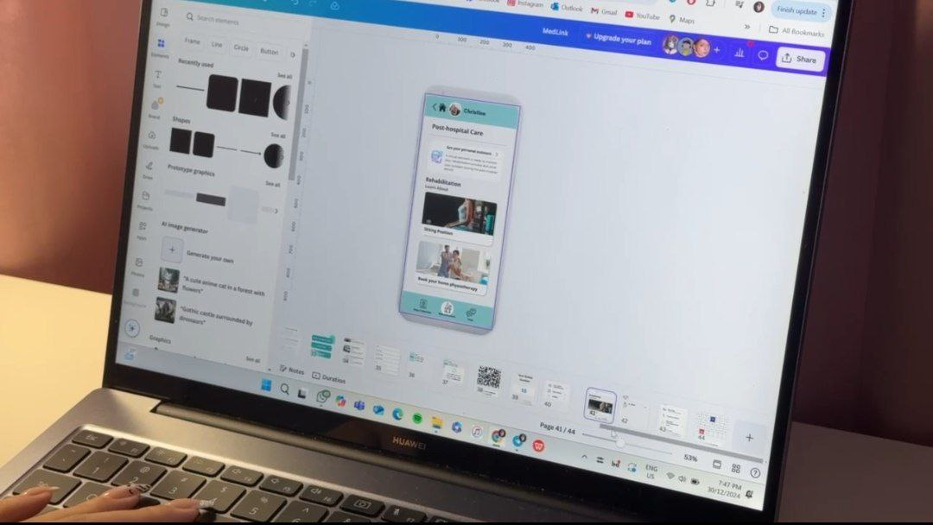

# Test

## 7.1 Testing

While testing, our tester provided positive feedback on the app’s sleek design, and usability. She believed that the app was somewhat effective in addressing challenges in Malaysia’s government healthcare system but suggested further improvements to tackle the complexity of these issues. She recommended us to focus more on appointment booking and medical records integration. Moreover, she suggested the implementation of an ID authentication system for doctors for security purposes.

## 7.2 Evidence

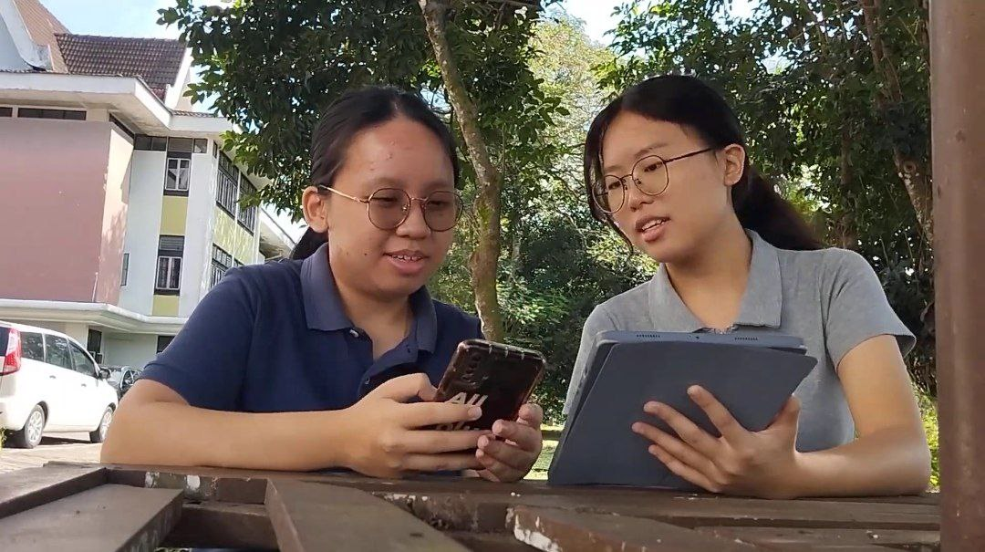

# 

# Assessment Point

In the **empathize phase**, we reviewed articles and news to understand the challenges faced by public and medical staff. Interviews gave us a direct perspective of how these issues impact the public's lives. Composite characters are developed to provide a clearer picture of the medical staffs’ pain points. While **defining**, we categorized the interviewees' problems into actionable problem statements, allowing us to focus on the users’ main concern.

During **ideating**, we brainstormed potential solutions and discussed the best options. It helps to have a clearer execution plan for the project. While **prototyping**, we designed the user interface (UI) with Canva and converted it into a testable prototype with Marvel. It showcased how the system functions in a real-world setting and allows us to modify before final implementation.

During **testing**, our tester provided positive feedback. She recommended us to focus on appointment booking and medical records integration. We identified areas for improvements and ensured the solution remains practical and effective for real-world use.

Summation, the MedLink app improves healthcare efficiency and accessibility by streamlining registration, centralizing records, and managing queues. Smart appointments, telemedicine, and emergency tools help reduce waiting time and ensure continuity of care. Whereas, centralized records preserve patient data. We provided an overview of the app’s potential to address issues in the government healthcare system, validating its effectiveness and user-centered design.

# Reflection

**Crystal Yap:**

1. Goal: To develop strong communication skills, a problem-solving mindset, and gain industrial exposure to prepare for future career.
2. Design thinking helps me to understand user needs, define problems effectively, and create innovative solutions, which are essential to develop effective and high-quality projects.
3. I want to improve skills in programming and multimedia tools by actively participating in industry workshops or visits and build my portfolio to support career goals.

**Aw Xu Yuen:**

1. Goal: To gain extensive opportunities to engage with industrial visits across various computing fields to enhance my practical experience.
2. Design thinking helps me address real-world challenges effectively, enabling me to participate in meaningful projects, enhance my practical skills.
3. I will attend more industry visits to deepen my knowledge and stay updated on current trends, participating in international competitions to gain practical experience.

**Nicole Lee:**

1. Goal: To gain comprehensive knowledge and practical skills in my field, enabling me to contribute innovative solutions to real-world problems.
2. Design thinking enhances my problem-solving ability and makes my solutions innovative yet practical.
3. I plan to involve myself in more project work to acquire hands-on experience by collaborating on projects dealing with real-world challenges.

**Sam Wei Leng:**

1. Goal: To have a full ability to run a formal and big project by myself or my team and become a respectful leader in my future career.
2. This design thinking project let me know what my disadvantages are and encouraged me to be a more uplifting and progressive person in improving myself.
3. I will have a deeper self learning plan since knowledge is endless and the community keeps advancing. The only thing I can do to not be eliminated in the industry is be a stronger me.

**Lai Shi Ni:**

1. Goal: To make an impact through technology, helping people in need and solving problems to improve the world.
2. Design thinking has taught me to think critically and creatively, actively seeking out problems in my life and others' to solve
3. I need to open up my eyes to notice the various problems faced by people in real life and how we can leverage the latest technology to solve the problems.

# 

# Task Distribution List

|  |  |
| --- | --- |
| **Group Member** | **Task** |
| Nicole Lee | Introduction & detailed description (problem, solution and teamworking) & video editing |
| Sam Wei Leng | Prototyping |
| Aw Xu Yuen | Video editing |
| Lai Shi Ni | Assessment points |
| Crystal Yap Wen Jing | Design Thinking Phases (Empathy & Testing) |

# References

1. Al-Shorbaji, Najeeb. 2021. “Improving Healthcare Access through Digital Health: The Use of Information and Communication Technologies.” In Healthcare Access. IntechOpen. <https://doi.org/10.5772/intechopen.99607>.
2. Ilyana Mukhriz, & Rachel Gong. 2023. *Putting patients first: Principles for future-facing electronic health records in Malaysia*. Khazanah Research Institute. <https://www.krinstitute.org/Discussion_Papers-@-Putting_Patients_First-;_Principles_for_Future-Facing_Electronic_Health_Records_in_Malaysia.aspx>
3. Su-Lyn, B. (1970, January 1). Hours-long hospital waits driving some to abandon treatment. *Malay Mail*. <https://www.malaymail.com/news/malaysia/2017/08/22/hours-long-hospital-waits-driving-some-to-abandon-treatment/1447711>
4. Kalianan, R. S., Woon, Y. L., Hing, Y. L., Leong, C. T., Lim, W. Y., Loo, C. E., & Low, L. L. (2022). Appointment structure in Malaysian healthcare system during the COVID-19 pandemic: The public perspective. *BMC Health Services Research*, *22*(1). <https://doi.org/10.1186/s12913-021-07456-3>
5. CodeBlue. (2024, February 13). *The unspoken reality of long waiting times in public hospitals — senior doctor*. CodeBlue. <https://codeblue.galencentre.org/2024/02/the-unspoken-reality-of-long-waiting-times-in-public-hospitals-senior-doctor/>
6. Shalihin, M. S. E., & Rifin, S. M. (2021). Patients’ waiting time in a university health clinic. *Malaysian Journal of Applied Sciences*, *6*(1), 21–26. <https://doi.org/10.37231/myjas.2021.6.1.268>
7. *Audit finds Malaysian hospitals understaffed, underfunded and overcrowded*. (n.d.). The Edge Malaysia. <https://theedgemalaysia.com/article/audit-finds-malaysian-hospitals-understaffed-underfunded-and-overcrowded>
8. Leow, H. T., & Liew, S. M. (2022). A cross sectional study on patient satisfaction and its association with length of consultation at the University Malaya Medical Centre Primary Care Clinic. *Malaysian Family Physician*, *17*(2), 71–80. <https://doi.org/10.51866/oa1339>
9. Wahab, S. N. A., Satar, N. N. M., & Tumin, N. M. (2022). URBAN POOR: EVIDENCE OF BARRIERS IN ACCESSING PUBLIC CLINICS IN KUALA LUMPUR, MALAYSIA. *Malaysian Journal of Public Health Medicine*, *22*(1), 193–204. <https://doi.org/10.37268/mjphm/vol.22/no.1/art.1148>